Lab: AWS EMR Deployment and Connecting to Cloud Storage (S3)

Introduction
In this lab we will spin up a Hadoop cluster on Amazon Elastic MapReduce (EMR) running one master node and two data nodes. For deployment, we will leverage Amazon Web Services (AWS) CloudFormation, a cloud Infrastructure as Code (IAC) platform. Additionally, for automating deployment and other configuration tasks you will use a Cloud9 development environment and the AWS command line interface.
Once infrastructure deployment is complete, we will connect to a public S3 bucket hosting an AWS Open Data dataset (NOAA surface readings) and bring that into our Data Lake using Python. Next, you will explore the differences between the Hadoop Distributed File System (HDFS) running on EMR and the EMR file system (EMRFS) backed by AWS S3. In this lab, we are using AWS S3 for data lake storage and Apache Spark on EMR for our data lake compute.

Pre-requisites
As a prerequisite to this lab you should have access to our class AWS environment via https://awsacademy.instructure.com.

Here is an overview of our lab environment:

Section 1: Initialize and upload lab files to your Cloud9 Environment

- Make sure you are signed into the AWS Console and using our classroom environment found here: https://awsacademy.instructure.com/login/canvas.

- Navigate to your Cloud9 environment via the AWS Console. If you deleted your previous Cloud9 environment, you may need to create a new one: https://console.aws.amazon.com/cloud9.

  - In network connection settings, select ‘SSH’. All other cloud9 settings can remain default.
  - Name your cloud9 instance whatever you would like, e.g. ‘cloud9-datalakeengineering’.

- Once your Cloud9 environment is up and running, open it and upload lab files:
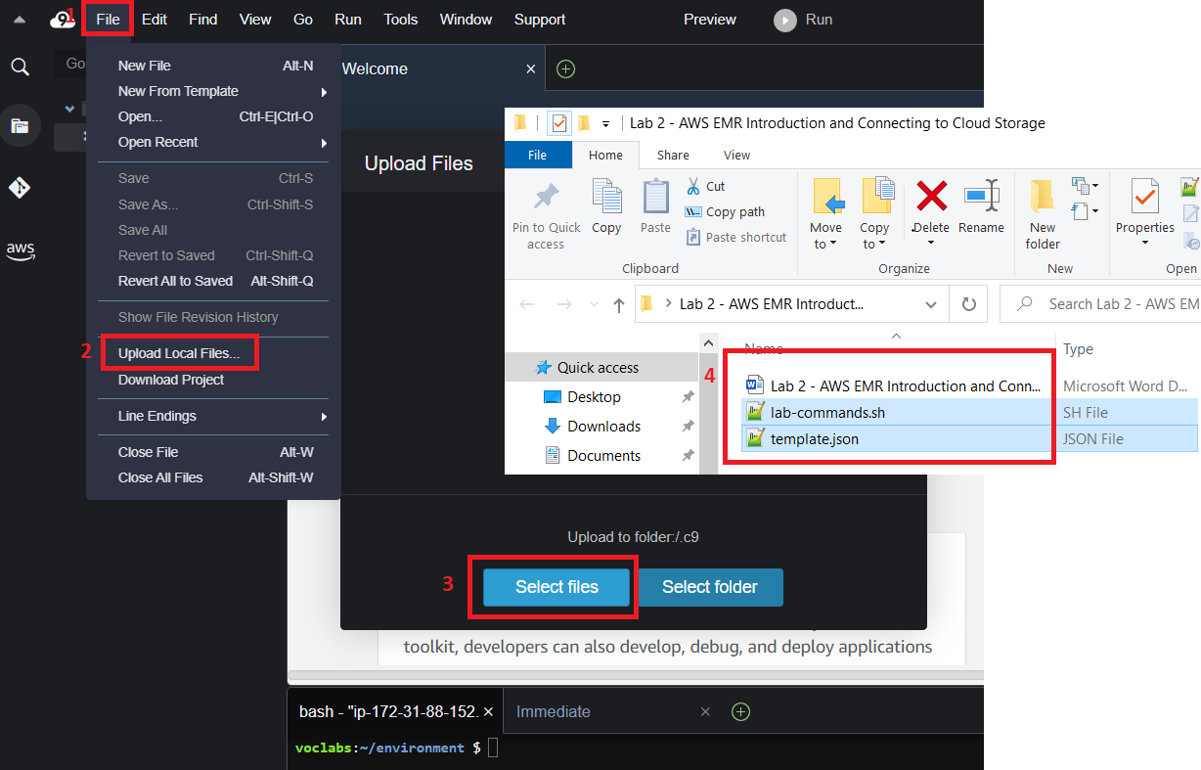

- Open lab-commands.sh within the Cloud9 text editor.
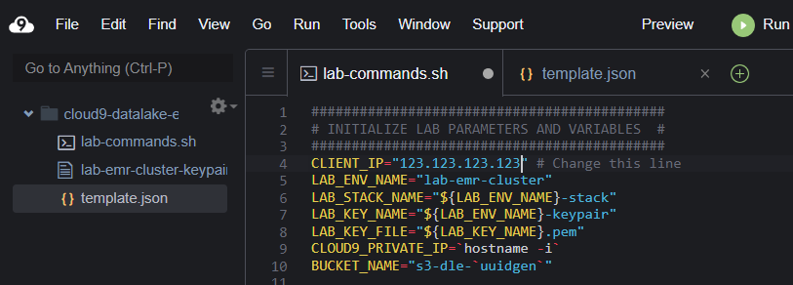
- Navigate to https://checkip.amazonaws.com and replace the 'CLIENT_IP' value in the script with the IP address on your web page. Note that this is the only value you will need to change within the script.
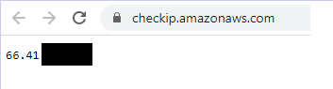
Note: If you normally have issues identifying your client IP address or connecting to services from your machine, feel free to enter "0.0.0.0" as your client IP. This will allow all inbound traffic to the box over ports specified for the duration of the lab. While this does pose a security risk it is a suitable workaround if you run into issues connecting.
Check IP:

Modify CLIENT_IP variable assignment in script:
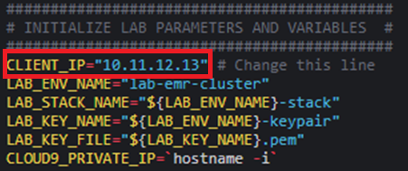

Section 2: Create a Hadoop cluster using Amazon Elastic MapReduce (EMR), CloudFormation, and the AWS CLI
Note: when executing commands from lab-commands.sh do so line by line. Be sure to observe the output on your Cloud9 terminal.
- In this section of the lab we will be creating our Hadoop cluster using Amazon EMR. First, copy/paste the first few lines to initialize some environment variables used through the script.
- CLIENT_IP is the IP address of your local machine for use in firewall rules
- LAB_ENV_NAME is the base name used for the AWS resources we create
- LAB_STACK_NAME is the name of our CloudFormation stack specified in template.json
- LAB_KEY_NAME is the name of the private key we will use to SSH to the instance
- LAB_KEY_FILE is the file name of the private key associated with the key name above
- CLOUD9_PRIVATE_IP is the IP address or the EC2 instance for your Cloud9 environment for use in firewall rules (we will SSH from our Cloud9 environment to the Hadoop master node). Note the script uses command substitution to dynamically retrieve the host name.
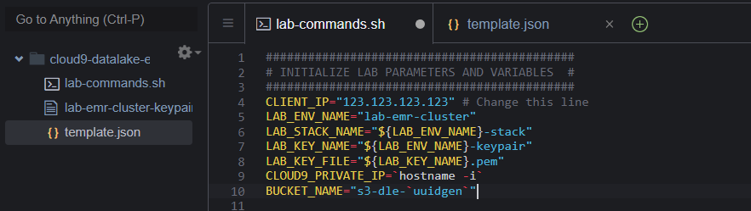

- Execute the next section of the script to create the lab infrastructure. We configure the AWS command line interface, append the appropriate CIDR suffix to the client IP address for use in firewall rules, create our AWS EC2 keypair for connecting to the cluster over SSH, and deploy the infrastructure defined in template.json. Note that there are multiple parameters that we pass in from the command line.
Note: If the AWS CLI returns an error here you may ignore it. An AWS CLI bug causes the command to timeout early. Note that this command can take some time (10 minutes or longer) as there are a lot of AWS resources being created by CloudFormation.
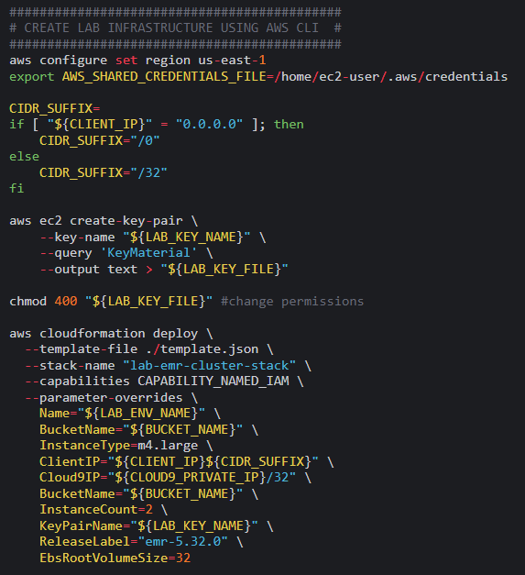

Section 3: Take a look at the new infrastructure then transfer files and connect to the Hadoop master node
- Navigate to the EC2 instances page. You should have four EC2 instances either starting or running. Note that these were created when we deployed our CloudFormation template above. Specifying infrastructure in formats like AWS CloudFormation is known as infrastructure as code (IAC). This helps keep infrastructure under version control and in synch between environments. It also makes it easy to destroy and recreate infrastructure.
EC2 instances at https://console.aws.amazon.com/ec2:
- A t2.micro instance used by our Cloud9 environments (your terminal window)
- A single Hadoop master node
- Two Hadoop data nodes

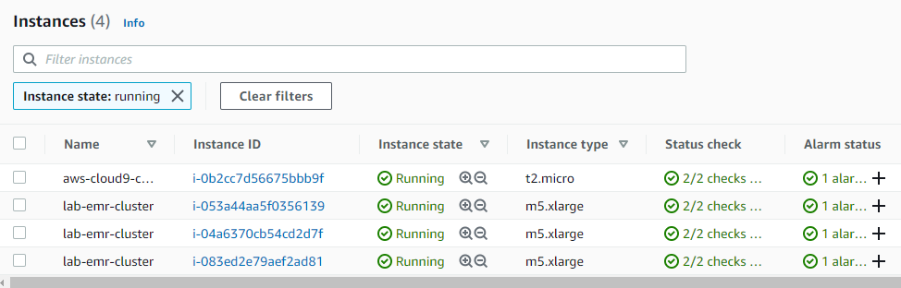

- The following commands first leverage the AWS CLI to identify the ID for our running Hadoop cluster, pause execution until the cluster is running, and query the public host (DNS) name of the master node. Then, we use the private key we created earlier to connect to the EMR master node.
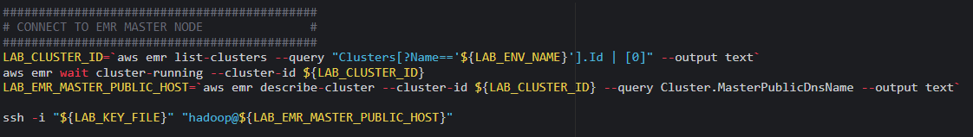

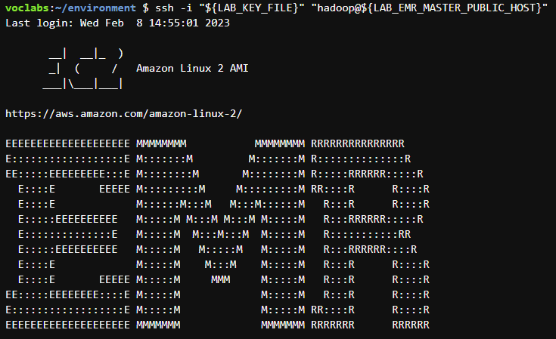

Section 4: Bringing data into the data lake
In this section, connect to the NOAA Global Surface Summary dataset hosted on AWS Open Data and S3 (an external S3 bucket). You will write this data both to HDFS and to S3. You may find details on this dataset here: https://registry.opendata.aws/noaa-gsod/.
- Open pyspark in your shell session. This will enable spark development in an interactive read, execute, print, loop (REPL). We will cover spark in more detail in later lectures. For now, read the dataset into a spark DataFrame from the external S3 bucket using EMRFS (note the s3:// scheme used in the code) and coalesce to reduce the number of files written in the next step:
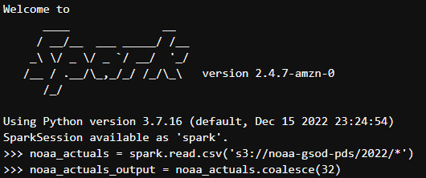

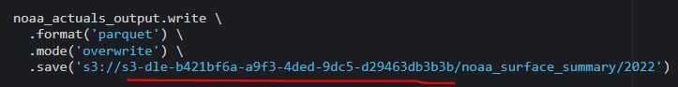
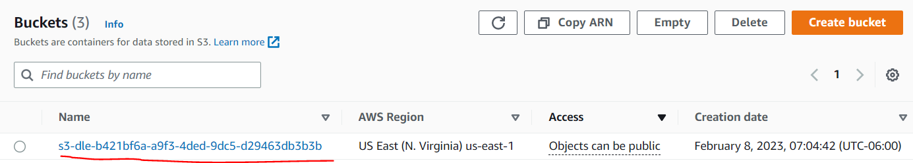
- Next, write the data to your external S3 bucket. Note that you will need to replace bucket_name with your S3 bucket ID. This can be found here: https://s3.console.aws.amazon.com/s3/buckets?region=us-east-1.
- Now we’ll write the weather data to our HDFS instance:
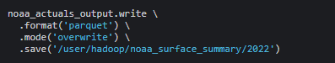

- Let’s explore the data and execute some operations in Spark. Show 10 records on the console, print the count of records, and execute some SQL to aggregate the high temperature. We’ll write the average high temperature to HDFS and exit the pyspark console:
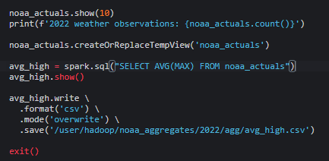

Section 5: Review output in HDFS and S3
- Leveraging the HDFS command line interface, list files in the noaa_surface_summary output directory.
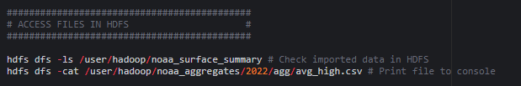
- From the AWS management console, find your S3 bucket and browse files. You may traverse the object namespace, download objects, delete objects, and more from the AWS console: https://s3.console.aws.amazon.com/s3/buckets?region=us-east-1

Section 6: Destroying your Amazon EMR Cluster and inspecting lab files
- In a normal production environment you would leave your big data environment up and running or leave the data stored on S3 for when you turn your cluster back on. However, since we are on a student lab budget we will destroy our environment at the end of each lab.

The AWS CLI has commands that make deleting an entire CloudFormation stack easy:
aws cloudformation delete-stack --stack-name "lab-emr-cluster-stack"

- Finally, reflect on the lab and inspect the template.json file and CloudFormation commands used to automate cluster deployment.

Conclusion
You have now used a running EMR cluster and Spark to bring data into our data lake from a remote source. Additionally, you have connected to both cloud storage (S3) and the HDFS instance running on EMR. Finally, you have taken small steps to explore and process data within a data lake environment. Reflect on the differences between cloud storage and HDFS that we covered during lecture.

